Report

Laboratory Work 6

Dmitry Ladutsko

August 14, 2022

# 

# 1. Prerequisites Task Information

## 1.1. Passwords Index

|  |  |  |
| --- | --- | --- |
| Password Group | Login Name | Password |
| Operation System | root | “rootadmin” |
|  | oracle | “oracleadmin” |
|  |  |  |
| Oracle System | sys | “sysadmin” |
|  | system | “sysadmin” |
|  |  |  |
| Oracle Users | All DB users | “%PWD%” |
|  |  |  |
|  |  |  |

## 1.2. Folder Paths Index

|  |  |  |
| --- | --- | --- |
| Path Group | Path Description | Path |
| Operation System | Oracle RDBMS – BIN | /oracle/app/oracle |
|  | Oracle Inventory | /oracle/app/oraInventory |
|  | Oracle Database Storage | /oracle/oradata |
|  | Oracle Install Directory | /oracle/install |
| Oracle | ORACLE_BASE | /oracle/app/oracle |
|  | ORACLE_HOME | $ORACLE_BASE/product/11.2 |
|  |  |  |
| FTP | ftp Incoming Folder | **/ftp/incoming** |
|  |  |  |
|  |  |  |

# 2. Business analyses tasks – Dimensions

## 2.1. Task 01: Create Packages for Reload Dimension from SA_*

**The Main Task** is to independent packages to reload dimension according your DWH solution concept which was developed on Module 6. Introduction to DWH.

***Note.*** Let’s rewrite package which move data from cleansing level (cl_employees) to DW level (dim_employees)

1. Use Execute Immediate with Bind Parameters:

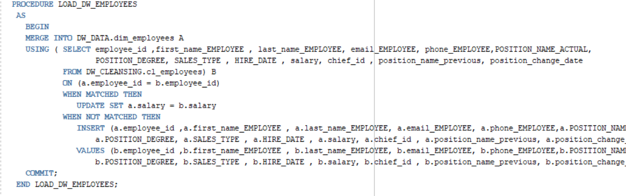

1. To_refcursor

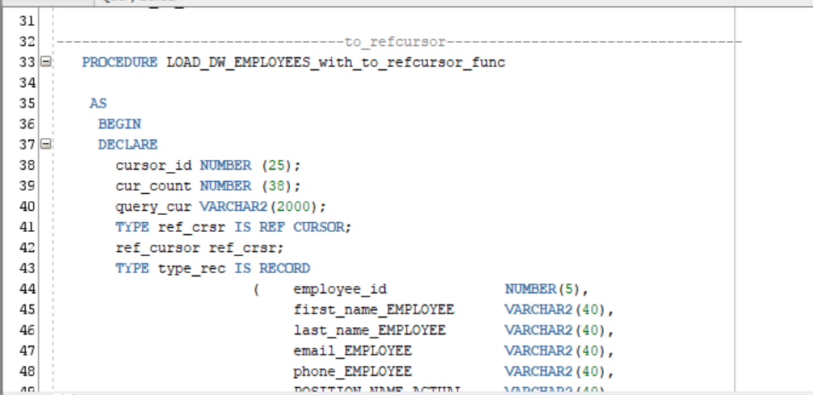

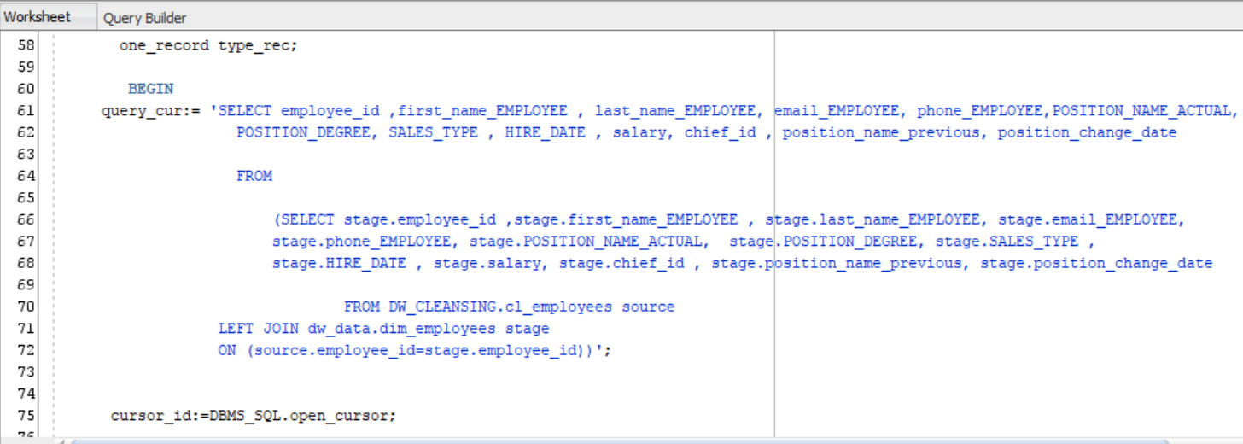

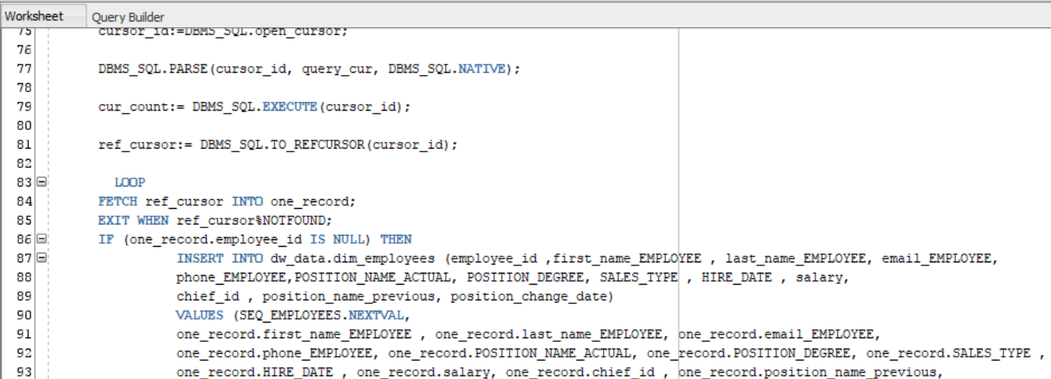

1. To_cursor_number

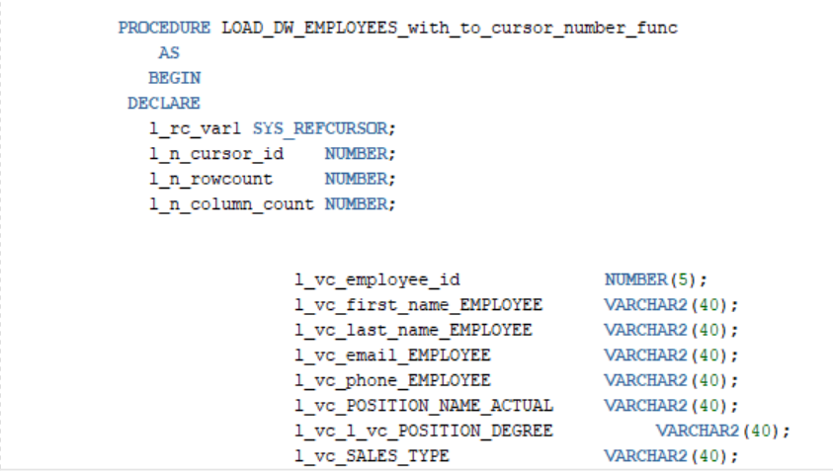

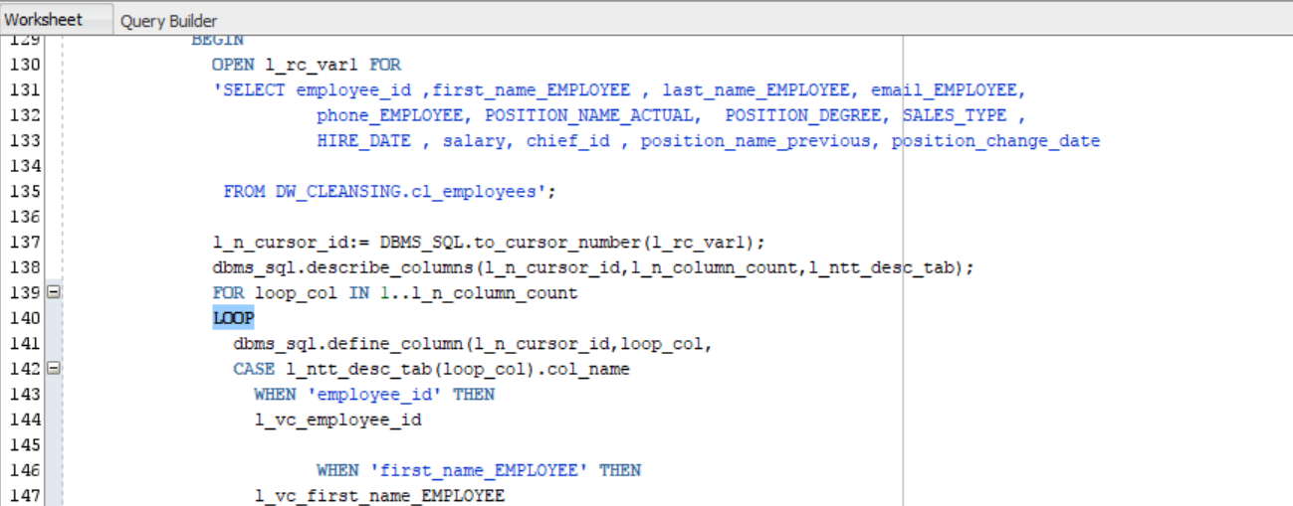

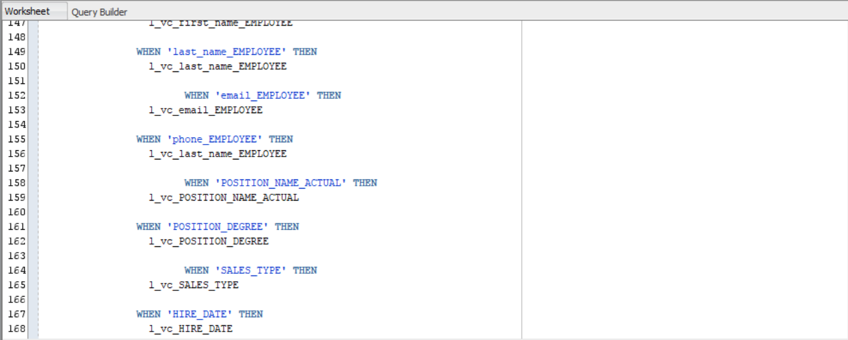

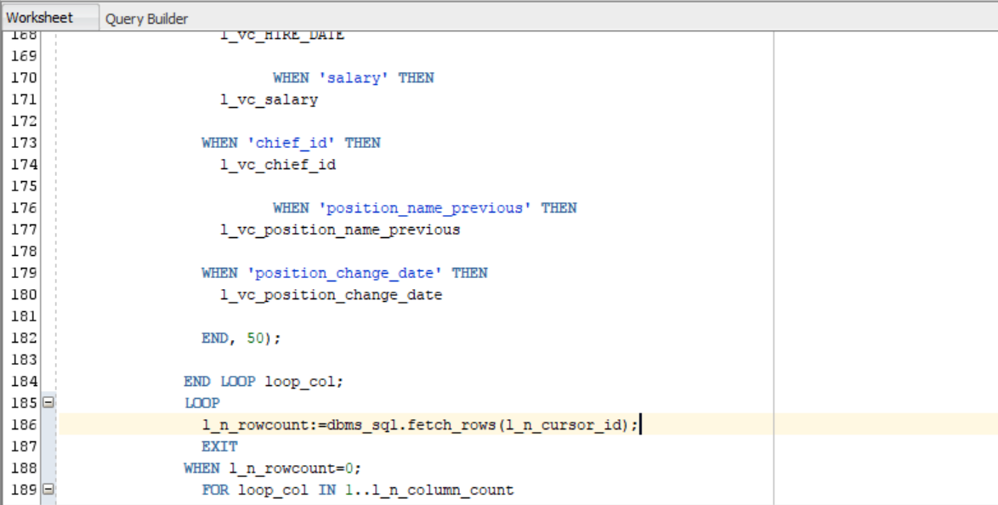

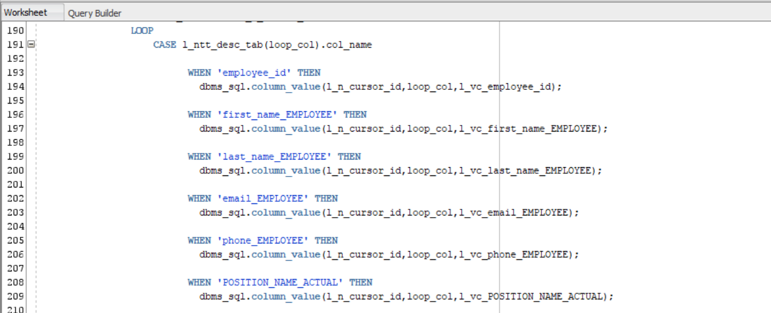

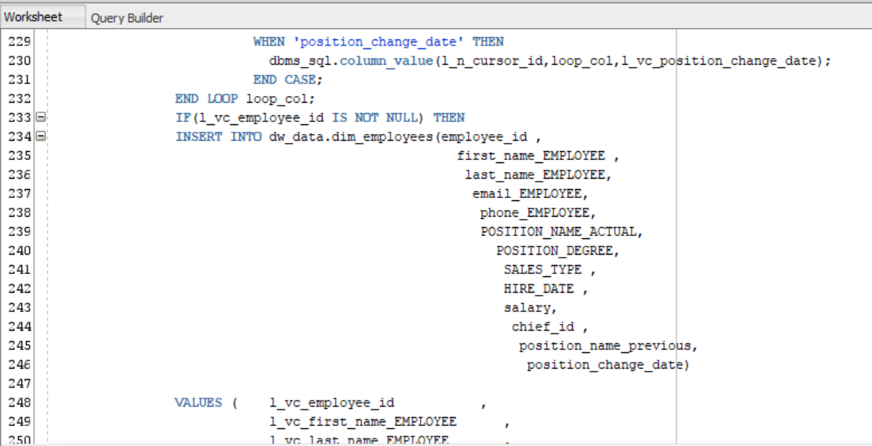

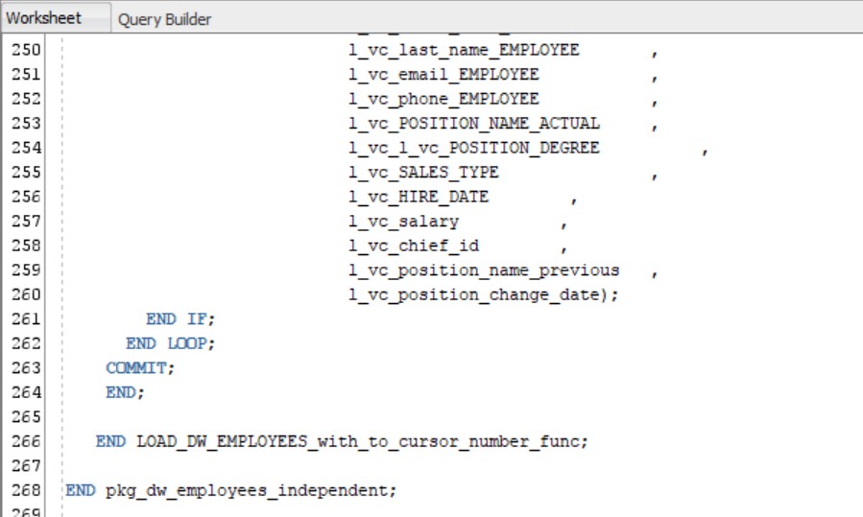

***Note.*** All packages rewritten. Let’ s execute the (and will not forget to truncate tables before executing to make sure packages work correctly)

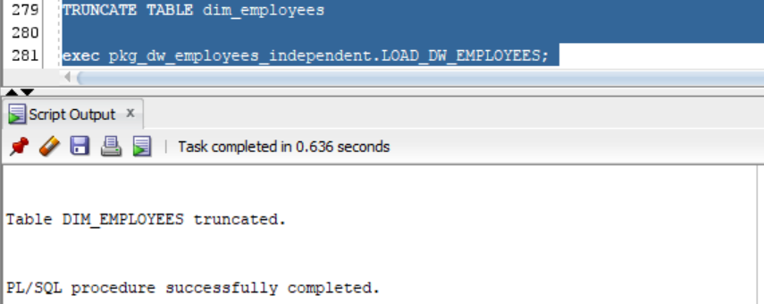

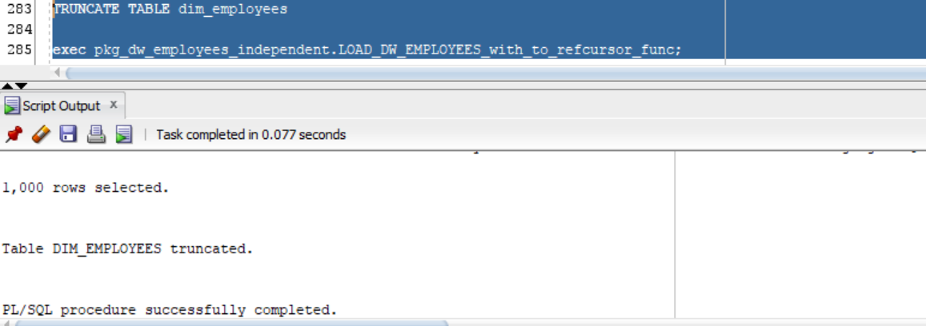

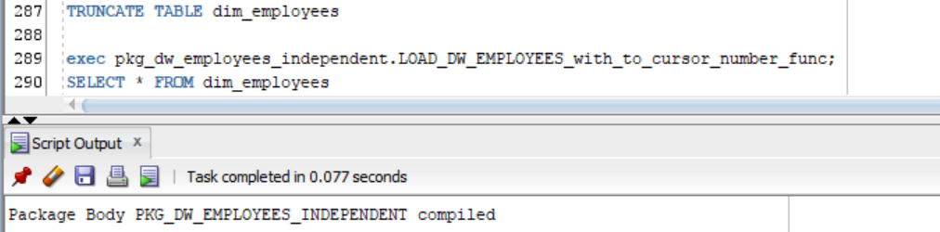

# 3. Business analyses tasks – Reports

## 3.1. Task 02: CREATE Monthly Reports Layouts

**The Main Task** is to create Reports Layouts according your Business Solution Proposal, which was developed on Exit Task Module 6.Introduction to DWH.

**Required points:**

* Refactoring Adhoc SQL, which was developed on Module 7 ETL - Extract, transform and load labwork 02;
* Use Module Clause

**Task Results:**

Create report layouts:

* Refactoring report layouts
* Put report layouts on Git – Folder BI Tasks – Product Name (author) - Repots

**Laboratory Work Summary:** At this laboratory work we practised usage of more types of data movement methods, such as:

* Use Execute Immediate with Bind Parameters
* Use DBMS_SQL.TO_REFCURSOR Function
* Use DBMS_SQL.TO_CURSOR_NUMBER Function